INSTITUTO CAMBRIDGE – Exams 2024

KIDS 3

NAME:

TIME: 1 hour 30 minutes

1

MARK SET

WRITE THESE TEN WORDS IN GROUPS | 10 x 0.1 = 1 mark

tuna flats motorway act chicken
sing pavement dance prawns houses

street |  | fish |  | dress up

CHOOSE AND CIRCLE | 5 x 0.2 = 1 mark

1 | What musical instrument do / does she play?
2 | There aren’t some / any olives on the pizza.
3 | What time / Where does Greg get up?
4 | The bracelet was / were on the table.
5 | Ania’s birthday is in / on July.

READ AND WRITE TRUE OR FALSE | 5 x 0.3 = 1.5 marks

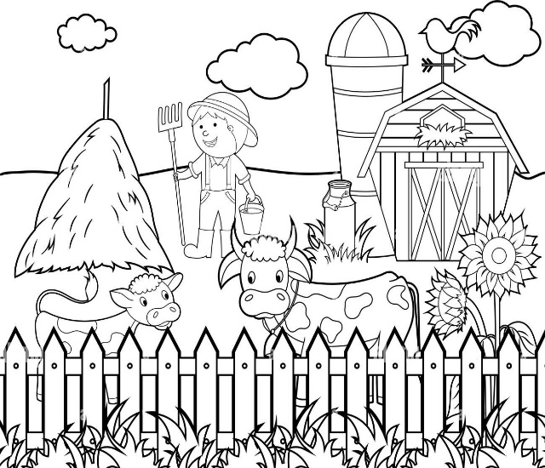 | 1 | This is a farm.
 | 2 | The young man is a doctor.
 | 3 | He’s happy.
 | 4 | There are two horses.
 | 5 | There are 2 flowers.

CIRCLE THE CORRECT ANSWER ‘a’ or ‘b’. | 5 x 0.3 = 1.5 marks

1- | Are Josh and Tim playing table tennis?
a |  | Yes, they are. | b | Yes, they were.
2- | Is there any tuna in the sandwich?
a |  | Yes, there are. | b | No, there isn’t.
3- | Were you at home yesterday?
a |  | Yes, you were | b | Yes, I was.
4- | Do you like Maths?
a |  | Yes, I do. | b | Yes, you do.
5- | Where does the band perform?
a |  | Yes, it does. | b | At concerts.

MATCH A LINE FROM ‘A’ WITH A LINE FROM ‘B’. Write the corresponding letter  from B in the box. | 5 x 0.3 = 1.5 marks

 | A | B |  |  | B
1 | I didn’t |  |  | a | is noodles.
2 | Nika is |  |  | b | watch TV yesterday.
3 | My favourite dish |  |  | c | lots of flats in my town.
4 | There are |  |  | d | to music on your tablet.
5 | You can listen |  |  | e | writing an email.

COMPLETE THE TEXT WITH THE WORDS IN THE BOX | 5 x 0.4 = 2 marks

pineapple fun always makes dinner

 | On Saturdays, I 1) __________ have dinner at my grandma’s house. She usually 2) __________ delicious pizzas. My favourite pizza has 3) __________on top. After 4) __________, I like making pancakes. They are 5) __________ to cook!

WRITING. Write 5 sentences using the words in the chart. Put the verbs in the correct form. | 5 x 0.3 = 1.5 marks

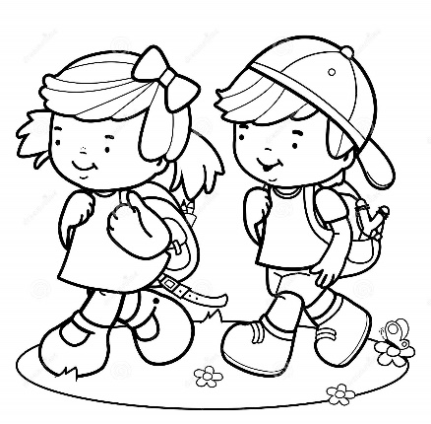 | This is my friend, Ben.
 | Ben / live / in my street.
 | Every day / we / walk to school.
 | We / not take / school bus.
 | I / like English / but / I / not like / Science.
 | Ben / like / Maths / but / he / not like History.
KD3-01
WRITE: street: flats, motorway, pavement, houses. Fish: tuna, chicken, prawns. Dress up: act, sing, dance.
CHOOSE: 1-does 2-any 3-what time 4-was 5-in
READ AND WRITE: 1T 2F 3T 4F 5T
CIRCLE: 1-a 2-b 3-b 4-a 5-b
MATCH A LINE: 1-b 2-e 3-a 4-c 5-d
COMPLETE: 1-always 2-makes 3-pineapple 4-dinner 5-fun

