INSTITUTO CAMBRIDGE – Exams 2024

KIDS 2

NAME:

1

TIME: 1 hour 30 minutes

MARK SET

READ AND NUMBER THE PICTURES | 5 x 0.2 =1 mark

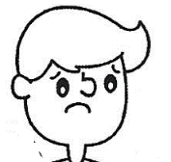 |  | 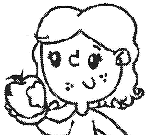 |  | 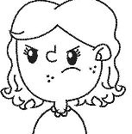 |  | 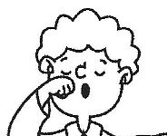 |  | 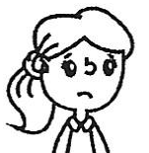

1- He's tired. | 3- She´s hungry. | 5- She´s sad.
2- She´s angry. | 4- He´s sad.

WRITE THE WORDS | 5 x 0.2 = 1 mark

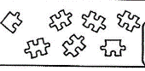 | 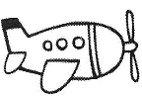 | 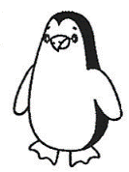 | 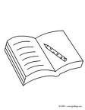 | 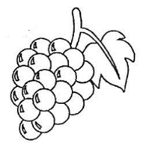
J _ _ _ _ _ | P _ _ _ _ | _ _ _ _ _ _ N | B _ _ _ | _ _ _ _ _ S

LOOK AND TICK. Tick the 5 correct sentences. | 5 x 0.2 = 1 mark

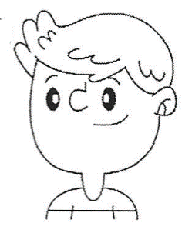 | 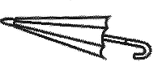  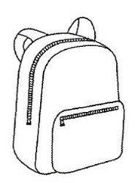   |  | 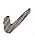 | 0 | This is his backpack.
 |  |  |  | 1- | These are her cars.
 |  |  |  | 2- | This is his umbrella.
 |  |  |  | 3- | These are his cameras.
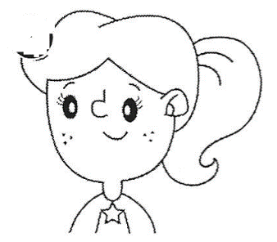 | 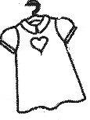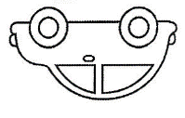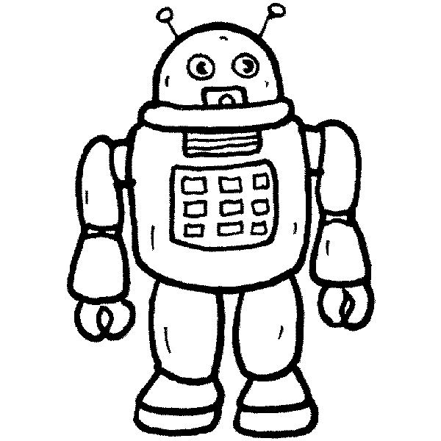 |  |  | 4- | These are her dresses.
 |  |  |  | 5- | These are his cars.
 |  |  |  | 6- | This is her robot.
 |  |  |  | 7- | This is her backpack.

READ AND CIRCLE. Look at the map and circle the correct prepositions | 5 x 0.3 = 1.5 marks

 |  |  |  |  | Museum |  |  | The park is above/next to the cinema.
 | Library |  |  | Station | Cinema | Park |  | The library is in front of/opposite the station.
 |  |  |  |  |  |  |  | The museum is behind/between the cinema.
 |  |  |  |  |  |  |  | The cinema is next to/between the station and the park.
 |  |  |  |  | Shop |  |  | The shop is opposite/above the cinema.

READ AND WRITE TRUE OR FALSE (T – F) | 5 x 0.3 = 1.5 marks

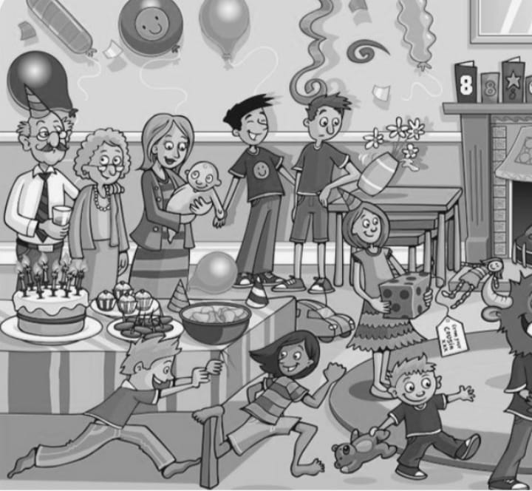 | 1- | The children are at a party.
 | 2- | There is a birthday cake on the table.
 | 3- | The small boy has got a teddy.
 | 4- | Grandpa is running.
 | 5- | Mum has got glasses.

READ AND MATCH. Write the corresponding letter in the box. | 5 x 0.4 = 2 marks

1 | I am singing. I am not doing ICT. |  |  | a | 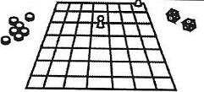
2 | He's a builder. He isn't a farmer. |  |  | b | 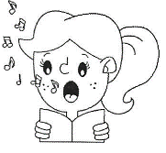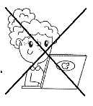
3 | I can play rugby. I can't do trampolining. |  |  | c | 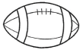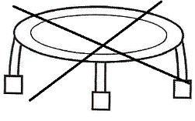
4 | I have got a board game. I haven't got a mobile phone. |  |  | d | 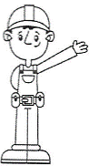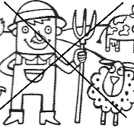
5 | I like fruit. I don't like sweets. |  |  | e | 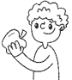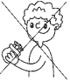

MATCH THE QUESTIONS FROM ‘A’ WITH THE ANSWERS FROM ‘B’. Write  the corresponding number from B in the box. | 5 x 0.4 = 2 marks

 | A | B |  |  | B
1 | Whose is this bottle? |  |  | a | Yes, I do.
2 | Are you doing science? |  |  | b | No, he is a scientist.
3 | Is he a doctor? |  |  | c | No, I am learning to play the piano.
4 | Do whales sleep in trees? |  |  | d | No, they don´t.
5 | Do you drink milk? |  |  | e | It’s mine.

KD2-01
READ AND NUMBER: 4-3-2-1-5
WRITE THE WORDS: 1-jigsaw 2-plane 3-penguin 4-book 5-grapes
LOOK AND TICK: 1-2-3-4-6
READ AND CIRCLE: 1-next to 2-opposite 3-behind 4-between 5-opposite
READ AND WRITE: 1-T 2-T 3-T 4-F 5-F
READ AND MATCH: 1-b 2-d 3-c 4-a 5-e
MATCH: 1-e 2-c 3-b 4-d 5-a

