INSTITUTO CAMBRIDGE – Exams 2024

KIDS 1

NAME:

TIME: 1 hour 30 minutes

2

MARK SET

READ AND TICK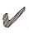OR CROSS. Put a tick or a cross in the box. | 5 x 0.2 = 1 mark

1 | This is a sandwich. | 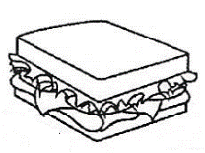 |  |  | 4 | This is a boat | 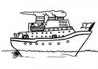
2 | This is a television | 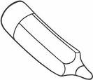 |  |  | 5 | This is a bag | 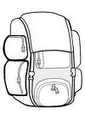
3 | These are socks | 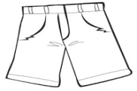 |  |  | 6 | This is a mouse | 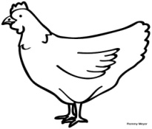

READ AND COLOUR THE PICTURE | 4 x 0.25 = 1 mark

Her head is pink.  Her nose is red.  Her T-shirt is green.  Her bird is orange. | 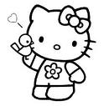

DRAW THE ANIMAL AND CIRCLE THE CORRECT WORDS | 5 x 0.4 = 2 marks

THIS IS A CAT
1- It can fly/jump.
2- It can’t swim/run.
3- It is black/green.
4- It’s got 4 eyes/legs.
5- It hasn’t got a tail/wings.

MATCH THE SENTENCES | 5 x 0.4 = 2 marks

1 | They are | a- play football
2 | I’m | b- a cat
3 | Leo can’t | c- pasta
4 | Poppy has got | d- cows
5 | I like | e- eight

READ AND DRAW ☺ OR ☹ | 5 x 0.4 = 2 marks

I’ve got a teddy and a ball.
I haven’t got a robot.
I haven’t got a bike.
I’ve got a doll.

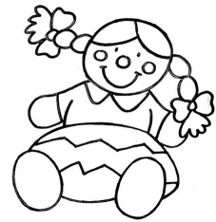 | 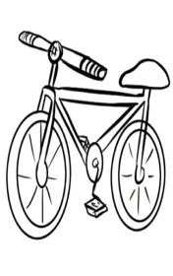 |  | 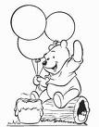 | 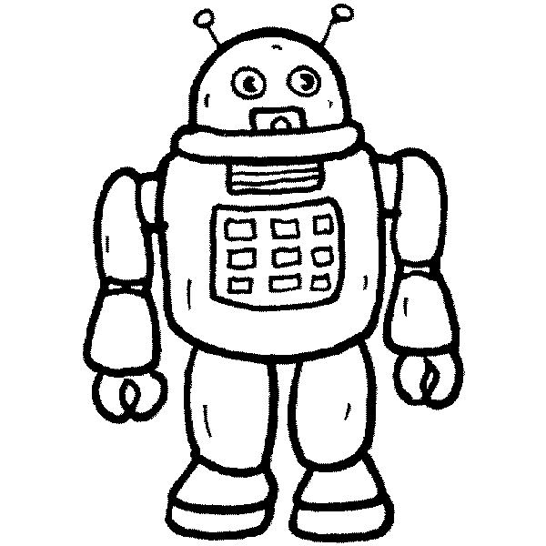
1- | 2- | 3- | 4- | 5-

ANSWER. Answer the questions using the words in the box. | 5 x 0.4 = 2 marks

Yes, I do - On the table - No, I can’t - No, I haven’t - It’s a pencil sharpener

1- | Can you swim?
2- | Do you like bananas?
3- | What’s this?
4- | Where is the book?
5- | Have you got a yoyo?

KD1- 02
READ AND TICK: 2 3 4 5 6
DRAW AND CIRCLE: 1 jump 2 swim 3 black 4 legs 5 wings
MATCH: 1d 2e 3a 4b 5c
READ AND DRAW: 1☺ 2 ☹ 3 ☺ 4☺ 5 ☹
ANSWER: 1 No, I can’t 2 Yes, I do 3 It’s a pencil sharpener 4 On the table 5 No, I haven’t

