**2024 KIDS ST SAMPLE ORAL EXAM**

# PART 1

1. **QUESTIONS BASED ON THE PICTURE**

Examiner: Hello…. Please, sit down. How are you?

Look at this picture, please

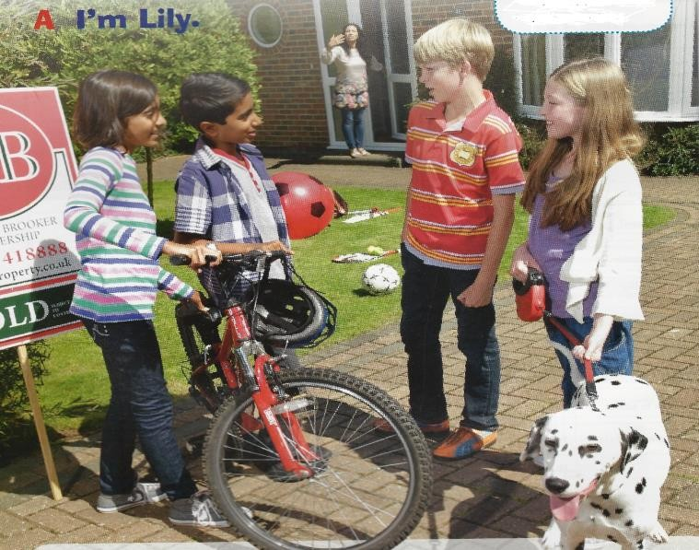

* + Where are the children? They’re in the garden.
  + (point at the bike) What’s this? It’s a bike.
  + What colour is it? It’s red.
  + How many balls are there? There are two balls.
  + Where is the white ball? It’s on the floor.
  + Are there any pets? Yes, there’s a dog.
  + Has it got a short tail? No, it hasn’t. It’s got a long tail.

# PERSONAL QUESTIONS

* + (Lucas) How do you spell your name?
  + How old are you?
  + Have you got any brothers or sisters?
  + What’s your favourite animal?
  + Have you got a pet? Describe it.
  + What’s its name?
  + What’s in your bedroom?
  + Is there a (TV)?
  + Do you go to school by bus?
  + Can you play the guitar?
  + Do you like swimming?

***NOTE: We will not necessarily ask all the questions in Part A and B***

**PART 2 QUESTIONS ON THE READER**: *The Skateboarder*