**2024 KIDS 2 SAMPLE ORAL EXAM**

# PART 1

1. **QUESTIONS BASED ON THE PICTURE**

Examiner: Hello…. Please, sit down. How are you?

Look at this picture, please.

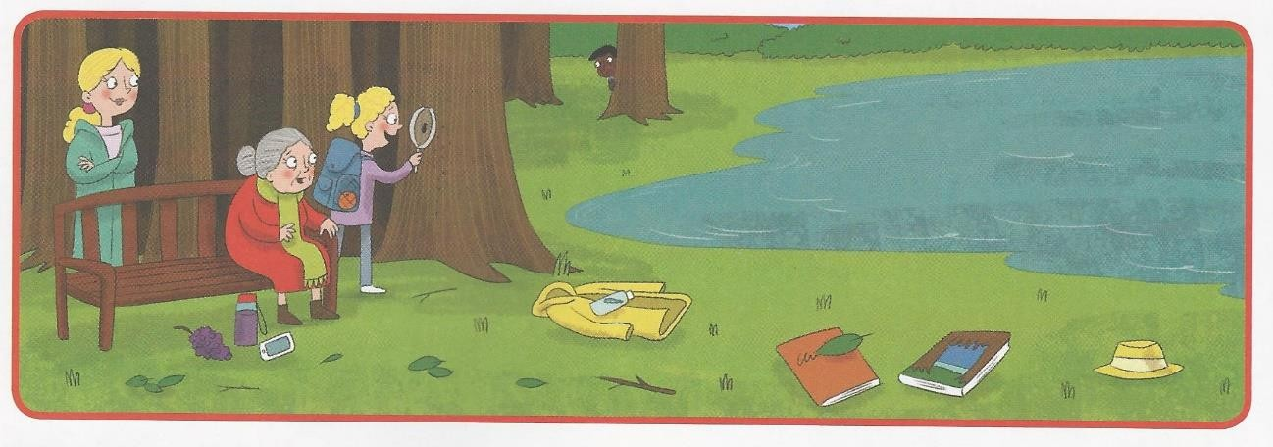

* + Where’s the boy? He’s behind a tree.
  + Are the children at school? No, they aren’t.
  + (pointing at an object) What’s this? It’s a book.
  + (pointing at the old lady) Is she grandma? Yes, she is.
  + Is the girl happy? Yes, she is.
  + Is she skipping? No, she isn’t.
  + What colour is the coat? It’s yellow.
  + Is there a lion in the picture? No there isn’t.

# PERSONAL QUESTIONS

* + How old are you?
  + Are you (happy) today?
  + When’s your birthday?
  + Have you got….?
  + Do you (actions) ….?
  + Is there (a park) (opposite) your house?

***NOTE: We will not necessarily ask all the questions in Part A and B***

# PART 2

**QUESTIONS ON THE READER:** *Jasper’s Pot of Gold*