**2024 KIDS 1 SAMPLE ORAL EXAM**

# PART 1

1. **QUESTIONS BASED ON THE PICTURE**

Examiner: Hello…. Please, sit down. How are you?

Look at this picture, please

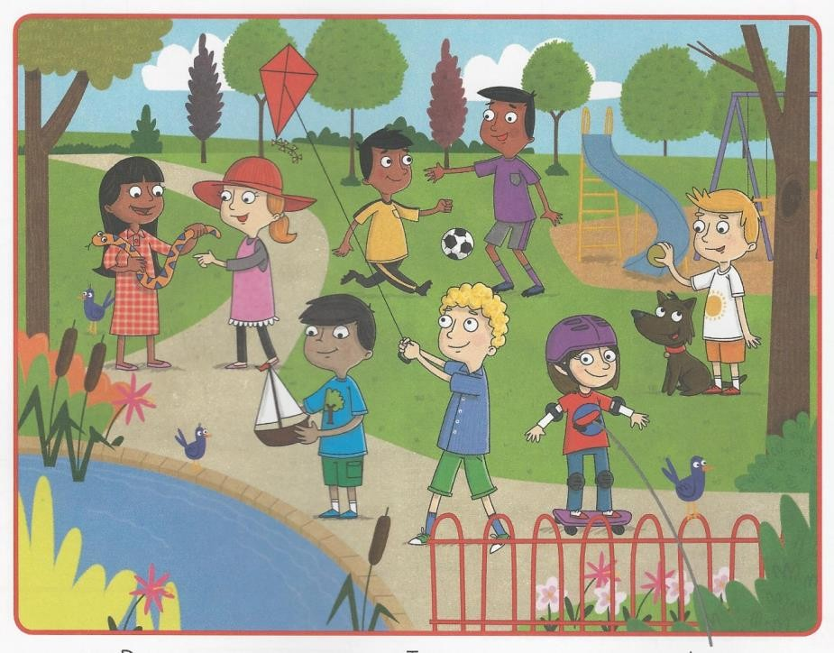

* + How many children can you see? Eight.
  + Where are they? They are in the playground.
  + (pointing at one of the girls) What has this girl got in her hands? She’s got a snake.
  + What colour is the snake? It’s blue and orange.
  + Can the boys play football? Yes, they can.

1. **PERSONAL QUESTIONS**
   * How are you today?
   * How old are you?
   * What are you wearing?
   * What’s the weather like today?
   * Can you… (abilities)?
   * Have you got ……?
   * Do you like….?
   * What colour is…..?
   * What do you have for (breakfast etc)?

***NOTE: We will not necessarily ask all the questions in Part A and B***

# PART 2

**QUESTIONS ON THE READER:** *The Princess and the Frog*