INSTITUTO CAMBRIDGE – EXÁMENES 2022
NAME:
KIDS 3
MOD 2
TIME: 1 hour 30 minutes

MARK SET

WRITE THESE TEN WORDS IN GROUPS | 10 x 0.1=1 mark

pop
rock
zoo read comics city forest
reggae play the piano beach classical

Folk |  | Lake |  | Do karate

CHOOSE AND CIRCLE | 5 x 0.2 = 1 mark

1 | Do / Does they play basketball?
2 | There aren’t any / some prawns.
3 | Use/ Don’t use your full name online.
4 | Where / When do you go swimming? At the club.
5 | We leave school at / in 4 p.m.

READ AND WRITE TRUE OR FALSE | 5 x 0.3 = 1.5 marks

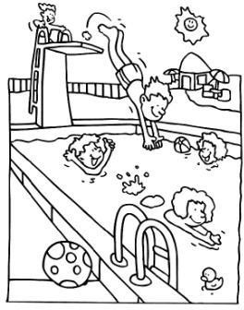 | 1 | There are five girls in the pool.
 | 2 | They are playing with a ball.
 | 3 | They’re angry.
 | 4 | It’s a sunny and beautiful day.
 | 5 | The ball is next to the pool.

CIRCLE THE CORRECT ANSWER ‘a’ or ‘b’. | 5 x 0.3 = 1.5 marks

1- | Was she at the playground yesterday?
a |  | Yes, she was. | b | Yes, she has.
2- | Does he play the violin?
a |  | No, he can’t. | b | No, he doesn’t.
3- | Is she eating pizza?
a |  | No, she isn’t. | b | No, she wasn’t.
4- | When does she perform?
a |  | Every day. | b | At concerts.
5- | Do you do karate?
a |  | Yes, I do. | b | Yes, I am.

MATCH A LINE FROM “A” WITH A LINE FROM “B”. Write the corresponding number from B in the box. | 5 x 0.3 = 1.5 marks

A |  | B |  | B
a- | Do you play |  |  | 1- | some fish and chips.
b- | She was |  |  | 2- | read comics everyday?
c- | She watches |  |  | 3- | in the park yesterday.
d- | I’d like |  |  | 4- | football?
e- | Does he |  |  | 5- | TV after school.

COMPLETE THE TEXT WITH THE WORDS IN THE BOX | 5 x 0.4 = 2 marks

board games goes at rollerskates morning

 | This is a picture of my sister. She is 12. She to school in the . She performs school concerts every year. She plays with friends. She has got .

WRITING Write 5 sentences using the words in the chart. Put the verbs in the correct form. | 5 x 0.3 = 1.5 marks

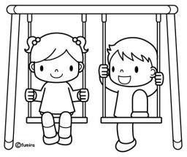 | These are my friends Mason and Tess.
 | They go to school / 8 a.m
 | They / not like / Maths .
 | Tess / not do / sport/ school.
 | Mason / play/ the drums at school concerts.
 | Tess/ dance/ and sing at concerts.

KD3-MOD 2

WRITE: folk: reggae, pop, classical, rock lake: beach, forest, zoo, city do karate: read comics, play the piano
CHOOSE: 1-do 2-any 3-Don’t use 4-Where 5-at READ AND WRITE: 1-F 2-F 3-F 4-T 5-T CIRCLE: 1-a 2-b 3-a 4-a 5-a
MATCH A LINE: a-4 b-3 c-5 d-1 e-2
COMPLETE: 1-goes 2-morning 3-at 4-board games 5-rollerskates

