INSTITUTO CAMBRIDGE – EXÁMENES 2022
NAME:
KIDS 3
MOD 1
TIME: 1 hour 30 minutes

MARK SET

WRITE THESE TEN WORDS IN GROUPS | 10 x 0.1=1 mark

tuna | cycle | flute | olives | mushrooms
skip | drums | cello | chicken | surf

SAIL |  | SWEETCORN |  | RECORDER

CHOOSE AND CIRCLE | 5 x 0.2 = 1 mark

1 | Does / Do Ben go up the hill?
2 | There is some / any spinach in the fridge.
3 | Don’t chat / Chat online with people you know.
4 | What time / Where do you go to sleep? At 11p.m.
5 | We play chess on / in Saturdays.

READ AND WRITE TRUE OR FALSE | 5 x 0.3 = 1.5 marks

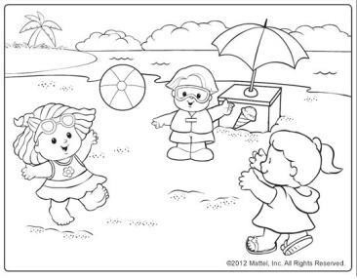 | 1 | There are three boys on the beach.
 | 2 | They are swimming.
 | 3 | They are on a farm.
 | 4 | They’ve got one ball.
 | 5 | The girls are jumping.

CIRCLE THE CORRECT ANSWER ‘a’ or ‘b’. | 5 x 0.3 = 1.5 marks

1- | Were you at the skate park yesterday?
a |  | Yes, I was. |  | b | Yes, I am.
2- | Do you like olives?
a |  | Yes, I do. | b |  | Yes, I have.
3- | Are they playing the piano?
a |  | No, they can’t. | b |  | No, they aren’t.
4- | Can she make cakes?
a |  | Yes, she can. | b |  | Yes, she does.
5- | What time is it?
a |  | It’s five past ten. | b |  | At five o’clock.

MATCH A LINE FROM “A” WITH A LINE FROM “B”. Write the corresponding number from B in the box. | 5 x 0.3 = 1.5 marks

A |  | B |  | B
a- | They were |  |  | 1- | play the recorder.
b- | Ben and Lily are |  |  | 2- | at the shopping centre yesterday.
c- | I sometimes |  |  | 3- | a pancake.
d- | Does she do |  |  | 4- | singing.
e- | I’d like |  |  | 5- | jigsaws?

COMPLETE THE TEXT WITH THE WORDS IN THE BOX | 5 x 0.4 = 2 marks

can ten plays brother masks

 | This is a picture of my . He is . He likes reading comics and making . He do karate very well. He video games. He has got a big guitar.

WRITING Write 5 sentences using the words in the chart. Put the verbs in the correct form. | 5 x 0.3 = 1.5 marks

 | These are my friends Noah and Ania.
They go to the park
/Sundays.
 | Ania have /many friends/ park.
 | She/like skating.
 | Noah/not play football.
 | He / go home/ at 6.

KD3-MOD 1

WRITE: sail: surf, skip, cycle sweetcorn: olives, tuna, chicken, mushrooms recorder: cello, flute, drums
CHOOSE: 1-does 2-some 3-Chat 4-What time 5-on READ AND WRITE: 1-F 2-F 3-F 4-T 5-T CIRCLE: 1-a 2-a 3-b 4-a 5-a
MATCH A LINE: a-2 b-4 c-1 d-5 e-3
COMPLETE: 1-brother 2-ten 3-masks 4-can 5-plays

