INSTITUTO CAMBRIDGE–EXÁMENES 2022
NAME:
KIDS 2

MOD
2
TIME: 1 hour 30 minutes
MARK SET

READ AND NUMBER THE PICTURES | 5 x 0.2 =1 mark

 |  | 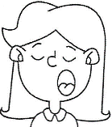 |  |  |  |  |  | 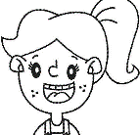

1- She’s happy. | 3- She’s thirsty. | 5- She’s tired.
2- He’s sad. | 4- He’s thirsty.

WRITE THE WORDS | 5 x 0.2 = 1 mark

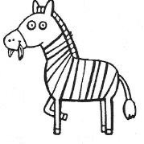 | 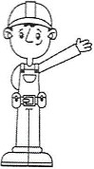 |  |  | 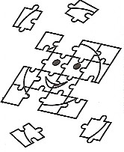
Z | _ R | C __ | __ E | __ W

LOOK AND TICK. Tick the 5 correct sentences. | 5 x 0.2 = 1 mark

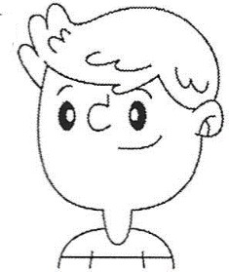 |   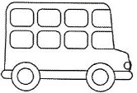 |  |  | 0 | This is her car.
 |  |  |  | 1- | This is his lorry.
 |  |  |  | 2- | These are her cameras.
 |  |  |  | 3- | These are his buses.
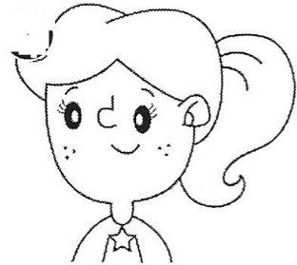 |   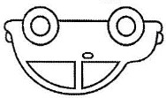 |  |  | 4- | This is her lorry.
 |  |  |  | 5- | These are her watches.
 |  |  |  | 6- | This is her watch.
 |  |  |  | 7- | This is her motorbike.

READ AND CIRCLE Look at the map and circle the correct prepositions | 5 x 0.3 = 1.5 marks

 |  |  |  | Restaurant |  |  |  | The library is in front of/opposite the  museum.
Library |  |  |  | School | Cinema | Shop |  | The cinema is next to/between the shop and  the school.
 |  |  |  |  |  |  |  | The park is behind/next to the museum.
 |  |  |  |  |  |  |  | The restaurant is above/between the school.
Museum | Park |  |  |  |  |  |  | The shop is behind/next to the cinema.

READ AND WRITE TRUE OR FALSE ( T – F ) | 5 x 0.3 = 1.5 marks

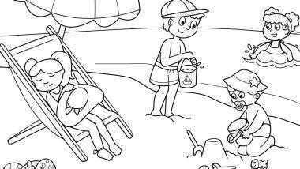 | 1- | The children are at school.
 | 2- | It is sunny and hot.
 | 3- | One girl is listening to music.
 | 4- | One girl is sleeping.
 | 5- | The boys are playing.

READ AND MATCH Write the corresponding number in the box. | 5 x 0.4 = 2 marks

a | He’s a waiter. He isn’t a farmer. |  |  | 1 | 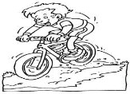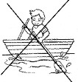
b | I go mountain biking. I don’t go rowing. |  |  | 2 | 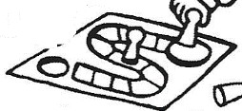
c | I like grapes. I don’t like sweets. |  |  | 3 | 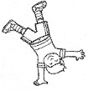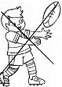
d | I’ve got a board game. I haven’t got a computer. |  |  | 4 | 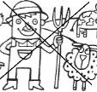
e | I can do athletics. I can’t play rugby. |  |  | 5 | 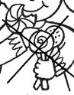

MATCH THE QUESTIONS FROM “A” WITH THE ANSWERS FROM “B”. Write  the corresponding number from B in the box. | 5 x 0.4 = 2 marks

A |  | B |  | B
a | Is he a scientist? |  |  | 1 | No, there aren’t.
b | Does it eat meat? |  |  | 2 | Yes, I do.
c | Are there any schools? |  |  | 3 | Yes, she is.
d | Do you like lemonade? |  |  | 4 | No, he’s a doctor.
e | Is she a zoo keeper? |  |  | 5 | Yes, it does.

KD2-MOD 2

READ AND NUMBER: 3 5 2 4 1
WRITE THE WORDS: 1-zebra 2-builder 3-cherries 4-plane 5-jigsaw
LOOK AND TICK: 1 2 3 6 7
READ AND CIRCLE: 1-opposite 2-between 3-next to 4-above 5-next to
READ AND WRITE: 1-F 2-T 3-F 4-T 5-T READ AND MATCH: a-4 b-1 c-5 d-2 e-3 MATCH: a-4 b-5 c-1 d-2 e-3

