INSTITUTO CAMBRIDGE – EXÁMENES 2022
NAME:
KIDS 2

MOD 1
TIME: 1 hour 30 minutes
MARK SET

READ AND NUMBER THE PICTURES | 5 x 0.2 =1 mark

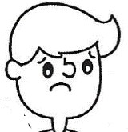 |  |  |  | 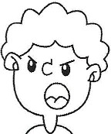 |  | 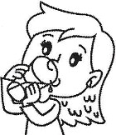 |  | 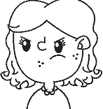

1- He’s angry. | 3- She’s thirsty. | 5- She’s angry.
2- She’s hungry. | 4- He’s sad.

WRITE THE WORDS | 5 x 0.2 = 1 mark

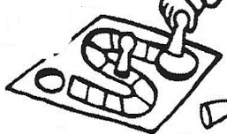 | 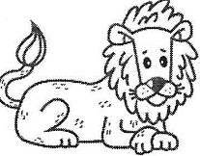 | 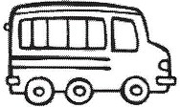 | 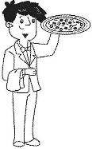 | 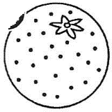
B __ __  G __ | N | S | W __ | O __

LOOK AND TICK. Tick the 5 correct sentences. | 5 x 0.2 = 1 mark

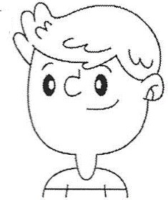 | 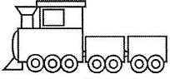    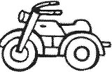 |  |  | 0 | This is his train.
 |  |  |  | 1- | These are his balloons.
 |  |  |  | 2- | This is his plane.
 |  |  |  | 3- | These are his cameras.
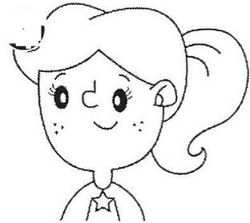 | 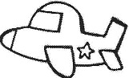  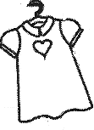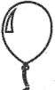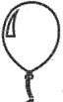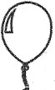 |  |  | 4- | This is her dress.
 |  |  |  | 5- | These are her planes.
 |  |  |  | 6- | This is his motorbike.
 |  |  |  | 7- | These are her balloons.

READ AND CIRCLE Look at the map and circle the correct prepositions | 5 x 0.3 = 1.5 marks

Park |  |  |  |  |  |  | The park is next to/opposite the cinema.
Cinema |  |  | Hospital | School | Library |  | The school is above/next to the hospital.
 |  |  |  |  |  |  | The school is behind/between the hospital and the library.
 |  |  |  |  |  |  | The cinema is next to/opposite the hospital.
 |  |  |  |  |  |  | The library is in front of/next to the school.

READ AND WRITE TRUE OR FALSE ( T – F ) | 5 x 0.3 = 1.5 marks

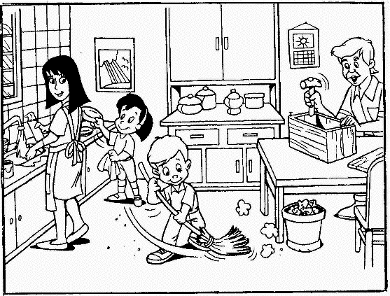 | 1- | They are in the kitchen.
 | 2- | There isn’t an animal in the picture.
 | 3- | The boy is dancing.
 | 4- | Dad is drinking water.
 | 5- | Mum is using her phone.

READ AND MATCH Write the corresponding number in the box. | 5 x 0.4 = 2 marks

a | I drink water. I don’t drink milk |  |  | 1 | 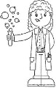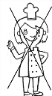
b | She’s a scientist. She isn’t a cook. |  |  | 2 | 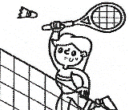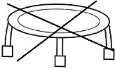
c | I’ve got a watch. I haven’t got a jigsaw. |  |  | 3 | 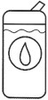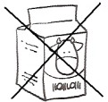
d | She isn’t a police officer. She’s a cook. |  |  | 4 | 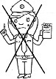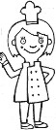
e | I can play badminton. I can’t do trampolining. |  |  | 5 | 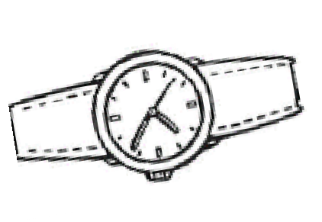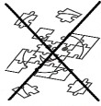

MATCH THE QUESTIONS FROM ‘A’ WITH THE ANSWERS FROM ‘B’. Write  the corresponding number from B in the box. | 5 x 0.4 = 2 marks

A |  | B |  | B
a | Are there any parks? |  |  | 1 | No, I don’t.
b | Is there a museum? |  |  | 2 | Yes, there are.
c | Do you go rowing? |  |  | 3 | Yes, he is.
d | Does it eat grass? |  |  | 4 | No, there isn’t.
e | Is he a farmer? |  |  | 5 | No, it eats meat.

KD2-MOD 1

READ AND NUMBER: 4 2 1 3 5
WRITE THE WORDS: 1-board game 2-lion 3-bus 4-waiter 5-orange
LOOK AND TICK: 3 4 5 6 7
READ AND CIRCLE: 1-next to 2-next to 3-between 4-opposite 5-next to
READ AND WRITE: 1-T 2-T 3-F 4-F 5-F READ AND MATCH: a-3 b-1 c-5 d-4 e-2 MATCH: a-2 b-4 c-1 d-5 e-3

